**User Manual**

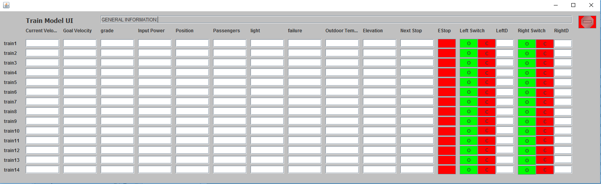

**Trian Model**:

Track model will pass authority and goal velocity and information about current track to train model. Train model will pass authority and goal velocity and current velocity to train controller. Trian controller will calculate power that needed to make the train reach goal velocity. The manual inputs for train model are Estop which means emergency stop and door control system.

**Display:**

The general information of trains will display in the block named “GENERAL INFORMATION”. Red button on the top right corner is the emergency stop button for all trains.

Current Velocity: display information of current velocity of certain train.

Goal Velocity: display the goal velocity of certain train.

Grade: display grade of the track.

Input Power: display input power which from train controller.

Position: display current location of certain train.

Passengers: display number of passengers currently on the train.

Light: display information of light system on the train.

Failure: display type of failure which occurred during travel.

Outdoor Temperature: display outdoor temperature.

Elevation: display current elevation of the train.

Next Stop: display next stop of train.

Estop: emergency stop button of each train.

Left Switch: left door switch, green button means open and red button means close.

Right Switch: right door switch, green button means open and red button means close.

LeftD: display current state of left door.

RightD: display current state of right door.

**Input from track model:**

Goal Velocity, Grade, Position, Outdoor Temperature, Elevation, Next Stop

**Input from train controller:**

Input Power, Left Switch, Right Switch

**Input from the users:**

Door switches, Estop

**Output to track model:**

Current velocity

**Output to train controller:**

Current velocity and authority